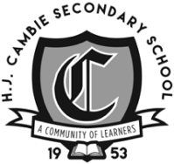  CAMBIE FAMILY WAAG | March 30 – April 3, 2026
 | Monday  March 30 | Tuesday  March 31 | Wednesday  April 1 |  | Thursday  April 2 | Friday  April 3
 | BADC  First Day back after Spring Break  B – A – D - C |  | BADC  Collab – School Starts at 9:50am  Valedictory fee to attend the ceremony and write up is due  The first 50 people who buy tickets for the Dinner dance, Valedictory, and Dry After Grad will have their names entered into a draw – to be refunded the costs of these events worth $260! |  |  | Good Friday  School Closed
  Block B | 8:30 – 9:38
  PLT | 9:43 – 10:31
  Block A | 10:36 – 11:44
  Recess | 11:44 – 11:59
  Block D | 11:59 – 1:07
  Lunch | 1:07 – 1:52
  Block C | 1:52 – 3:00
  Block B | 8:30 – 9:38
  PLT | 9:43 – 10:31
  Block A | 10:36 – 11:44
  Recess | 11:44 – 11:59
  Block D | 11:59 – 1:07
  Lunch | 1:07 – 1:52
  Block C | 1:52 – 3:00
 | All of us at Cambie wish our Cambie Families a happy, healthy and safe Spring Break. Please see the info below for some Spring Break events and activities happening around Richmond.  Things to do this Spring Break in Richmond  The City of Richmond is offering some low-cost and free family-friendly events and activities over the upcoming Spring Break (March 14-29).  Make the most of the school break with swimming, skating, nature adventures, exhibitions and more. Explore exciting day camps, drop-in fun and registered activities (in-person and online programs for all ages).  Mother’s Day and Spring Flowers  We will be selling spring plants again this year to help support the Dry Grad events.  Plants will go on sale right after spring break, and you will be able to order up until April 22.  Beautiful plants will be available for pickup at the school on Thursday, May 7.  Just in time for Mother’s Day or adding beauty to your home and yard.  Dear Grade 11 and 12 Parents and Guardians,  We hope you are doing well.  As we look ahead to celebrating our students’ upcoming graduation, we want to ensure that our Cambie grads have the safe, memorable Dry Grad experience they deserve. However, we urgently need your help.  At this time, Cambie’s Dry Grad Committee does not have enough volunteers to run the event. Without parent involvement, Dry Grad cannot happen.  We have also barely begun fundraising, and this puts the event further at risk. If families are unable to participate in fundraising efforts, we kindly ask that you consider contributing through a monetary donation instead. Every contribution—whether time, effort, or financial support—makes a meaningful difference.  Dry Grad is an important tradition that provides our students with:  - A safe, supervised environment to celebrate their graduation  - A fun and inclusive event shared with classmates  - A milestone memory that marks the end of their high-school journey  We want every Cambie grad to have this opportunity, but we cannot move forward without committed parent volunteers.  If you are willing to join the committee, help with fundraising, or offer a donation, please reach out as soon as possible.  📧 Contact: Vinicius Melo - vbmelo.ca@gmail.com or Raj Bains – rajgosal@hotmail.com  📅 Next Meeting – TBD (dependent on volunteers)  Thank you for supporting our grads and helping keep this important event alive.  Dry Grad Committee  Please may we take your Refundable?    We now have blue plastic bins ready to collect your refundable items such as pop cans, juice containers, milk cartons, etc. Please help our PAC and Dry After Grad committees work to raise money to support the Dry After Grad event. We have a blue plastic container placed in the entry in front of our school office. Every little bit helps.  Grade 7 Jamboree  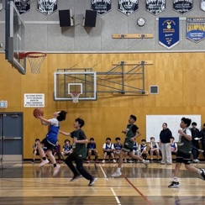  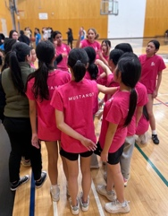  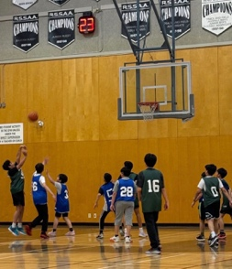  This Wednesday, Rec Leadership proudly hosted our annual Grade 7 Jamboree, welcoming the girls’ and boys’ teams from McNeely, Tait, and Mitchell. It was a great day of basketball, teamwork, and school spirit as students competed, cheered each other on, and showed fantastic sportsmanship throughout the event. In addition to the games, students also had the chance to participate in an exciting Hot Shot Competition, testing their shooting skills and adding even more energy to the day. A big thank you to everyone who helped organize and run the event, as well as to the visiting schools for making it such a fun and memorable jamboree!  Student Learning Surveys – for Parents  Parent surveys are available to be completed by parents with children in Grades 4, 7, 10, 11 and 12 at https://www.awinfosys.com/SurveyFull1/central/main/access_Parent.asp until May 1, 2026. It is available in 18 different languages, and the survey will take approximately 30 minutes to complete  Hot Lunch - Don't Miss out!  Here is the link for you to use for registration and login instructions for the Feeding Futures program, including screenshots:  https://munchalunch.com/docs/sd38/FF  Menus for the remainder of the school year have been uploaded, allowing parents to place orders for February, March, April, and June in one sitting, if you so choose. Each date includes one meat or one vegetarian option, with dairy-free, gluten-free, and halal options available.  We hope that you do register your child for these lunches.  *** PLEASE NOTE: Registration/ordering a lunch closes 5 days before the actual lunch distribution date ***  Richmond United Football Club    Our youth soccer club is the perfect place for children to learn, grow, and have fun. Through exciting practices and games, players build teamwork, confidence, discipline, and leadership skills in a positive and supportive environment. Soccer helps children stay active while learning important life lessons both on and off the field. See the attached flyer for contact information.  Volunteer Cultural Interpreters Needed  The Richmond School District is seeking individuals who are fluent in English and other languages to join our Volunteer Interpreter Team. We are seeking your support to get the word out to families about this important opportunity.  Help strengthen communication between schools and families by providing language support during parent-teacher conferences. Your involvement helps ensure that every family feels welcomed and informed.  Training is provided. All languages are welcome. |  |  | DATES TO REMEMBER:  Important Grad Information  - The $65 Valedictory fee to attend the ceremony is due by April 1. The Valedictory grad write-up submission form is also due by April 1.  The first 50 people who buy tickets for the Dinner dance, Valedictory, and Dry After Grad will have their names entered into a draw – to be refunded the costs of these events worth $260!  - Go to the school website for more information: https://hjcambie.sd38.bc.ca/students/graduation/valedictory-ceremony  - The Valedictorian, Poet & Historian application form is open on the school website. The application deadline is April 10. Go to the school website for more information: https://hjcambie.sd38.bc.ca/students/graduation/class-valedictorian-historian-and-poet  - Dinner Dance will be held at Mayfair Lakes Golf and Country Club on June 23, 2026. Tickets will cost $130 - please pay on SchoolCashOnline by May 1.  - Dry Grad will be held at Cambie Secondary immediately following the Dinner Dance celebrations. Tickets will cost $65 - please pay on SchoolCashOnline by May 1.  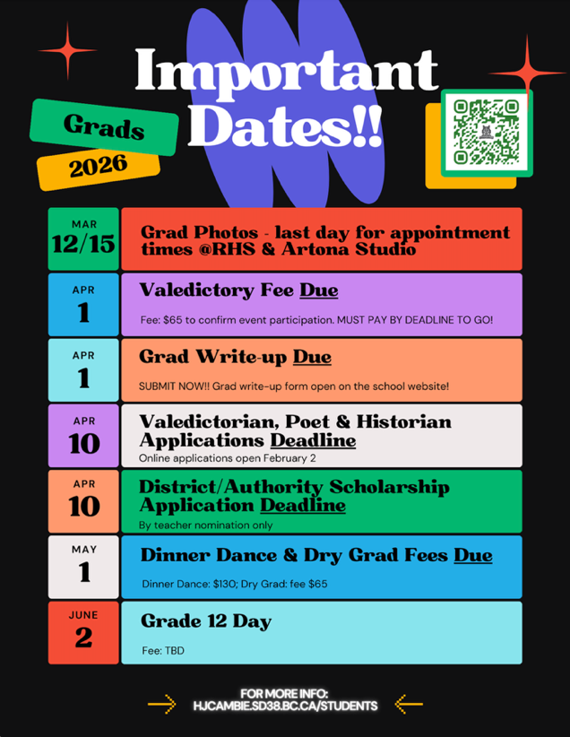  Scholarship Opportunities for Grade 12 students  Information from BC School Sports Please note that BC School Sports will no longer be offering BCSS funded scholarships. However, we remain committed to supporting student-athletes and our member schools in meaningful ways. Moving forward, BCSS will continue to promote and administer a selection of third-party scholarships, including BC Dairy, Molten, and the Bert & Greta Quartermaine Badminton.  For detailed criteria, eligibility requirements, and application instructions, please refer to the Scholarship Booklet. 2025-2026 Scholarship Booklet.  BCIT Entrance Award  BCIT is excited to offer Entrance Awards to students planning to start their studies between  May 1, 2026, and April 30, 2027  - Up to 25 BCIT President’s Entrance Awards, available only to current BC High School students  - Valued up to $4,000 each.  - Deadline: April 15, 2026  - Over 200 additional Entrance Awards  - Some valued up to $20,000 each.  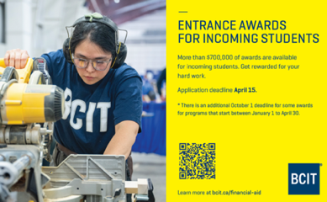  Deadlines: April 15 and/or October 1, 2026  To learn more about BCIT Entrance Awards and how to apply online, visit our website.
  Mar. 30 | First Day back after Spring Break
  April 1 | Valedictory fee and write up are due
  April 1 | Collab – School Starts at 9:50am
  April 3 | Good Friday – School Closed
  April 6 | Easter Monday – School Closed
  April 8 | Hot Lunch – Gr. 8 & 9
  April 9 | Hot Lunch – Gr. 10 - 12
  April 10 | Valedictorian, Poet & Historian application DEADLINE
  April 20 | BLOCK ROTATION – C – D – A – B
  April 22 | Provincial Grad Assessment – Numeracy 10
  Apr. 22 - 26 | Senior / Jazz Band Tour
  April 28 | Hot Lunch – Gr. 8 & 9
  April 29 | Hot Lunch – Gr. 10 - 12
  April 29 | S2 Midpoint Learning Updates Published

